Ticket Volume Forecasting Models
Two weekly forecasting models for Chile ticket volumes. One predicts total tickets. The other predicts only the tickets that turn into a work order. Both are tested the same way, using past weeks to predict the next week.

1. How the models were built (workflow)
1. Load and clean the data
Read daily ticket data. Count tickets per day. Fill in any missing days with zero.
2. Split into two time windows
Tune window: 25 weeks, used to test settings and pick the best ones. Holdout window: the next 25 weeks, used only once at the end to check real performance.
3. Build features for the model
For each day: day of week, whether it is a Chile public holiday (or the day before/after), recent average ticket volume, and the same weekday's volume in past weeks.
4. Try SARIMAX (a time series model)
Tested 20 different settings on the tune window. Picked the setting with the lowest error.
5. Try a Poisson GLM (a regression model)
Tested a few feature combinations on the tune window. Picked the version with the lowest error.
6. Blend the two models
Tried mixing SARIMAX and GLM in different proportions (0% to 100%) to see if a blend beats either model alone.
7. Test on the holdout window
Ran the final, locked-in model on the 25 holdout weeks it had never seen. This is the real accuracy number.
8. Check the worst weeks
Looked at the weeks with the biggest errors to understand what caused them, for example one-off spikes in daily volume.

2. Model A: Work Order Forecast
Predicts the weekly number of tickets that get a work order (has_work_order = "Y"). This is a smaller subset of all tickets.

Tune window results
Model | Tune error (MAPE)
SARIMAX, tuned settings | 16.57%
GLM (best version) | 14.67%
Best blend | 100% GLM, 0% SARIMAX, 14.67%

Holdout window results (final check)
Model | Holdout error (MAPE)
Simple average of last 4 weeks | 14.51%
SARIMAX, tuned settings | 15.62%
Final model: GLM alone | 16.14%
SARIMAX, default settings | 18.17%
Final model: GLM alone. On average it forecasts about 9.3 work orders per week too low. The two worst weeks were 2026-06-07 and 2026-07-26, both over 30% off.
Note: a simple 4-week average (14.51%) did slightly better than the tuned model (16.14%) on this holdout. See open questions below.
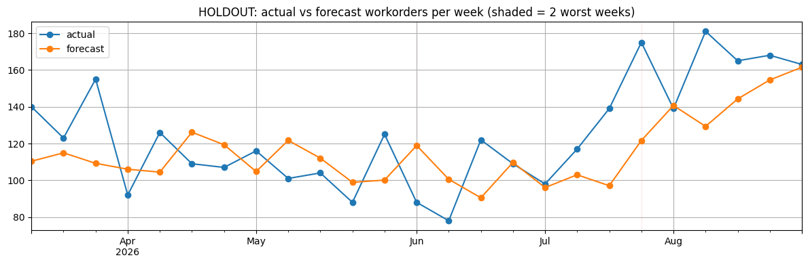
Holdout: actual work orders per week vs. the model's forecast. Shaded bands mark the two worst weeks.

3. Model B: Total Ticket Forecast
Predicts the weekly number of all tickets, no work order filter. Uses 613 days of data, from 2024-12-26 to 2026-08-30, averaging about 152.6 tickets a day.

Tune window results
Model | Tune error (MAPE)
SARIMAX, tuned settings | 12.95%
GLM (best version) | 10.83%
Best blend | 75% GLM, 25% SARIMAX, 10.46%

Holdout window results (final check)
Model | Holdout error (MAPE)
Final model: blend (75% GLM, 25% SARIMAX) | 12.64%
GLM alone | 13.01%
Simple average of last 4 weeks | 13.34%
SARIMAX, tuned settings | 13.42%
SARIMAX, default settings | 14.78%
Final model: blend of 75% GLM and 25% SARIMAX. Worst weeks were 2026-05-10 (44.0% error, caused by a one-day spike to 897 tickets on 2026-05-06) and 2026-07-26 (30.3% error).
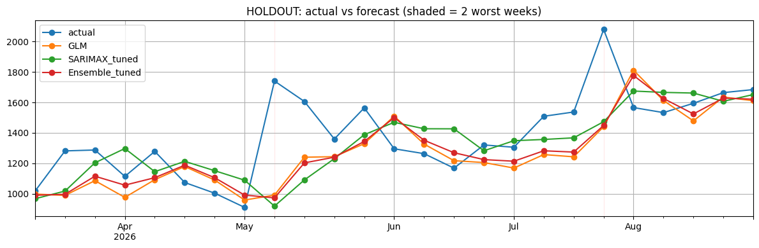
Holdout: actual tickets per week vs. GLM, tuned SARIMAX, and the final blended model. Shaded bands mark the two worst weeks.

4. Summary
 | Model A: Work Orders | Model B: Total Tickets
Best model | GLM alone | Blend: 75% GLM, 25% SARIMAX
Tune error | 14.67% | 10.46%
Holdout error | 16.14% | 12.64%
Beats simple 4-week average? | No, 14.51% is better | Yes, beats 13.34%

5. Open questions and next steps
- Model A: a simple average beats the tuned model on the holdout. Worth checking if the GLM is overfit to the tune window, or if work orders need different features.
- Both models miss badly in weeks with real spikes or dips, such as holidays or one-off surges. Consider handling outliers before training.
- Re-check both models on a rolling basis as new weeks of data come in, instead of one fixed holdout split.

